Play with Bootstrap - 2
Send Feedback

This is your second assignment for Bootstrap. Explore 'Buttons', 'Dropdown' and 'Stretched Link' component on Bootstrap.

On a large screen and above, it looks like -
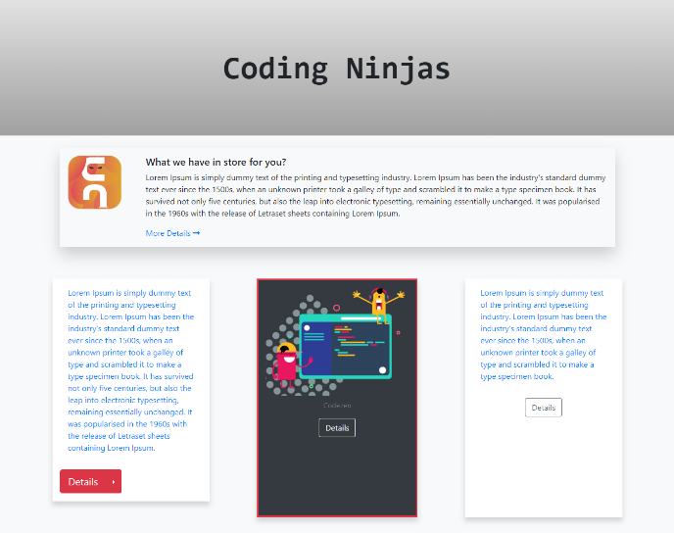

On a medium screen and above, it looks like -
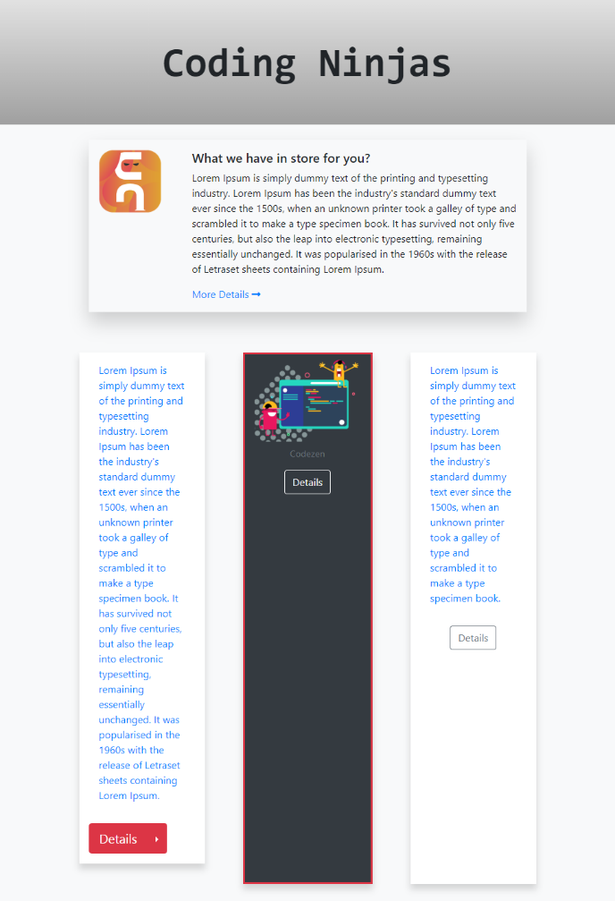

On a small screen and above, it looks like -
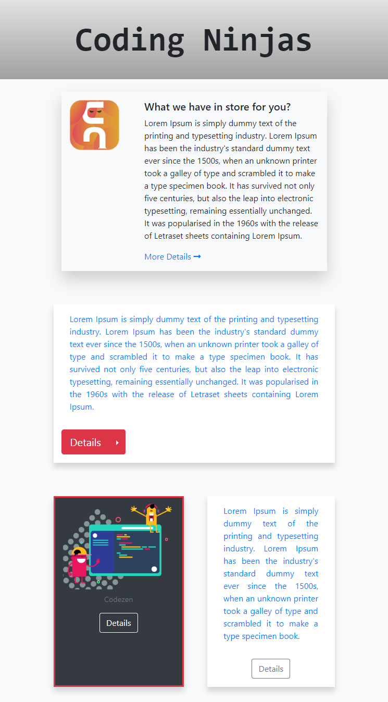

On a small screen and below, it looks like -
